Project – B-Investor Mobile App

Group 2:

Wagner Ferreira

Gabriele Dupont

Sai Hoi Yeung



Department, Bow Valley College

SODV3203: Mobile Application Development

24JAMMN

Pedro Henrique Ferreira

15th February 2024

**Introduction**

In the fast-paced world of finance, where every decision can have significant implications, we recognized the need for a platform that bridges the gap between theoretical knowledge and practical experience. Inspired by the desire to empower individuals to make informed investment decisions, we conceived the idea for B-Investor - a stock trading simulator app.

**Features**

**1. Sign up for an account**

Users can easily create a personalized account on B-Investor. Provide basic information, set up a user profile, and start exploring the world of simulated stock trading.

**2. Login/Logout**

Users can seamlessly access the B-Investor account with a secure login process. Enjoy the convenience of a quick and straightforward login and ensure the security of the simulated portfolio. When trades are done, log out to keep the account information safe.

**3. Make a deposit / Withdraw money**

When users create the B-Investor account, they can select the starter deposit (e.g. 1. $5,000, 2. 15,000, 3. 30,000) to store in the investment account.

**4. Check the Stock List**

Access a comprehensive stock list within B-Investor to explore a diverse range of stocks. Browse through the available options and stay informed about the various stocks you can include in your simulated portfolio.

**5. Search Stock by the code**

Users can use the unique stock code for searching specific stock and checking its details.

**6. Add/Remove Watch List**

Customize the trading experience by curating a personalized watchlist. Add stocks to monitor closely and receive timely updates on their performance. Easily manage the watchlist by removing stocks that no longer align with the trading strategy.

**7. Buy/Sell Stock**

Experience the excitement of virtual trading with the ability to buy and sell stocks within B-Investor. Execute market orders and practice the trading in a risk-free environment.

**Wireframe**

**Sign in**

**Sign up**

**Home**

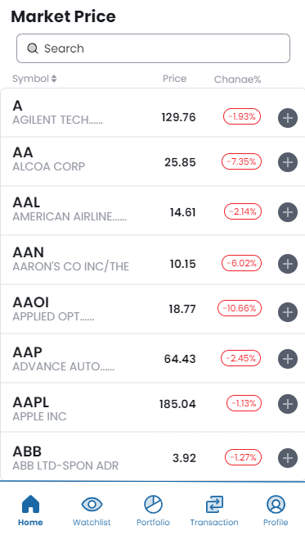

**Watchlist**

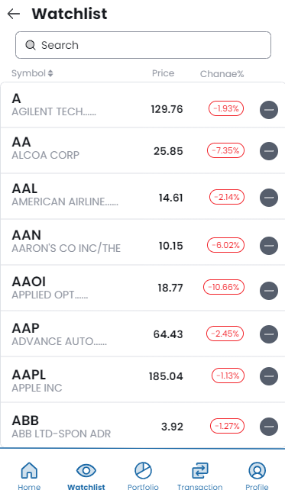

**Portfolio**

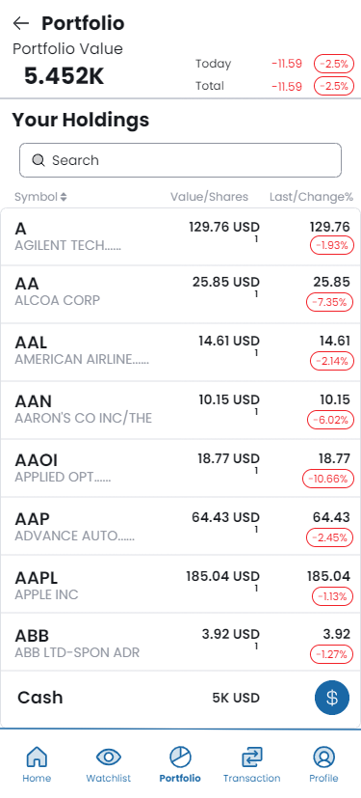

**Transaction**

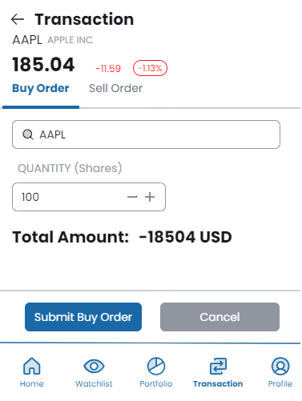

**Profile**

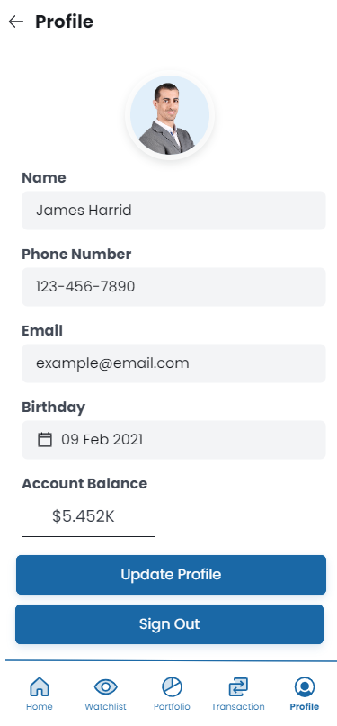

**Update Profile**

